Jonathan Greenberg

2/17/2020

Project Report #3

1. Observation from the paper. Taking into account: distance to the basket, defensive pressure, skill (shooting percentages, how many points they average, etc.) Other factors may include fatigue, defensive pressure on shooting?

https://stats.nba.com/players/shooting/?Season=2019-20&SeasonType=Regular%20Season&sort=8-16%20ft.%20FGM&dir=1

Observation from paper that I can feed off:

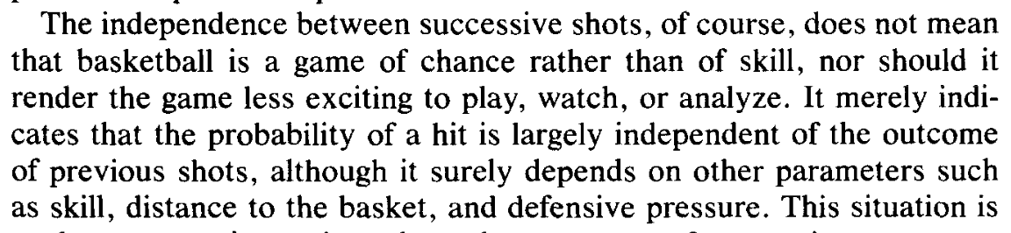

Possible obstacle: granularity: One issue I may have is that I won’t be able to find a dataset with the granularity of each successive shot in the dataset. However, I found this dataset recently so if I decide to go this route at any point I can:

<https://www.kaggle.com/dansbecker/nba-shot-logs>

2. Think about a new question but based on bigger data. How to make use of the filters to get interesting data for the prediction model.

Question: Can we predict the success of a shot based on the player shooting, player defending, distance from the hoop, minutes played already in that game, previous successes, etc?

Question: Which teams takes more pressure shots? Which teams make the most pressure shots, which player takes the most pressure shots? This all goes into determining and predicting the success of any particular shot.

Question: Can we predict a team’s shooting percentage on any given night/matchup?

3. Regarding the topic of Injuries:

Can we determine whether load management has any truth to the method? There has been some research into this field but no one really knows if it works. The method is basically resting your stars

So the question boils down to: Can we determine a player’s risk of injury for a particular game or season? Does resting stars help their endurance in the long run?

Load management as a research topic:

<https://www.espn.com/nba/story/_/id/28066201/nba-load-management-know-know>

Write again what do want to predict and think about the model. What kind of model. What are the pieces of your model? Regression? Classification?

I would like to use a classification: Injured or not? Can we determine if a player will get injured. Or maybe ask on the team level. How many injuries is this team likely to experience and see if it correlates with any of the coaching methodologies and how the team plays its players. Additionally test if it correlates with any of the physical attributes of players.